**VISUALIZATION TOOL FOR ELECTRIC VEHICLE CHARGE AND RANGE ANALYSIS**

**1 .INTRODUCTION**

* 1. OVERVIEW

An exploration of electric vehicles and their uses are to be discussed below. Through this project, we can define that the electric vehicle (EV) is not new, but it has been receiving significantly more attention nowadays. A vehicle that can be powered by an electric motor that draws electricity from a battery and is capable of being charged from an external source and have an electric motor instead of an internal combustion engine.

* 1. PURPOSE

The purpose of this project is to know about the electric vehicle, their uses and their demerits. This is to solve the problems acquiring in the vehicles. Its goal is to reduce vehicular emissions and air pollution in the country. Electricity is to power the electric vehicles. They don’t produce any emissions or exhale any toxic gases.

**2. PROBLEM DEFINITION AND DESIGN THINKING:**

**EMPATHY MAP :**

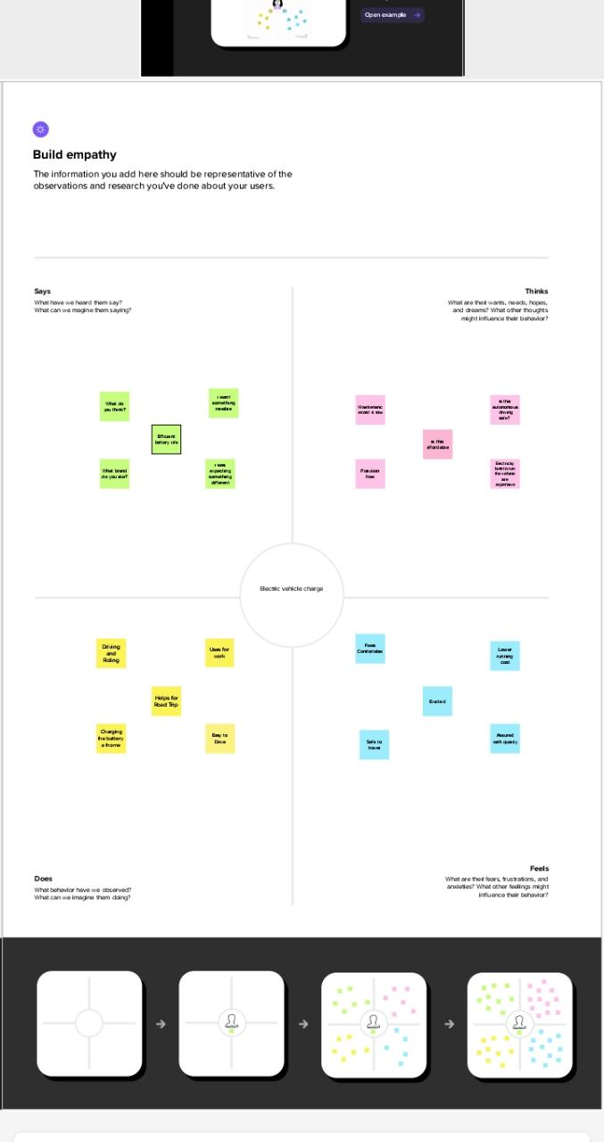

IDEATION & BRAINSTORMING MAP:

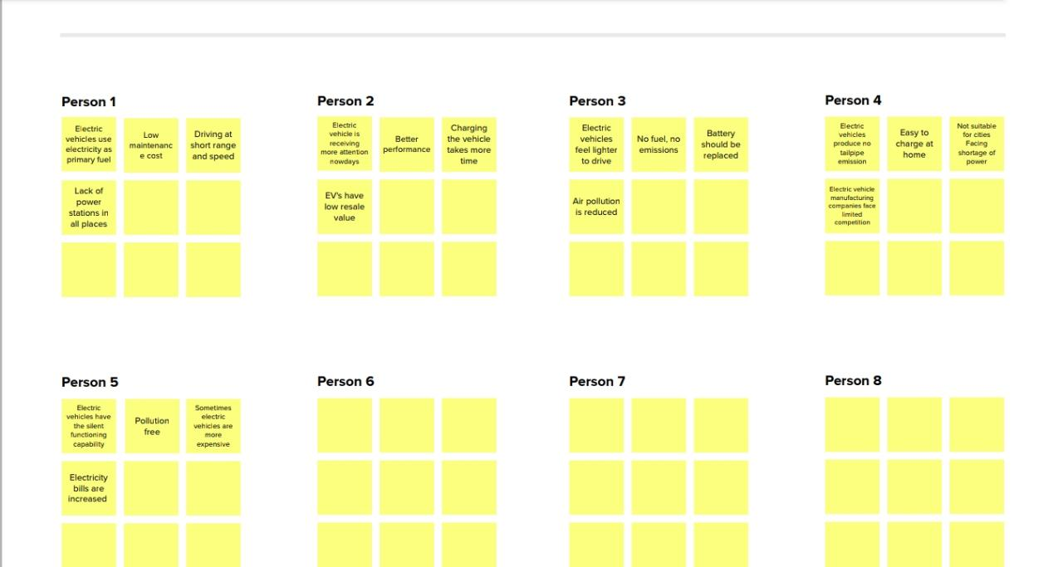

**3. RESULT**

Through this project we know that, electric vehicles have a battery instead of a gasoline tank and an electric motor instead of an internal combustion engine. How they are being used? The demerits and the problem acquiring in the vehicles are discussed. 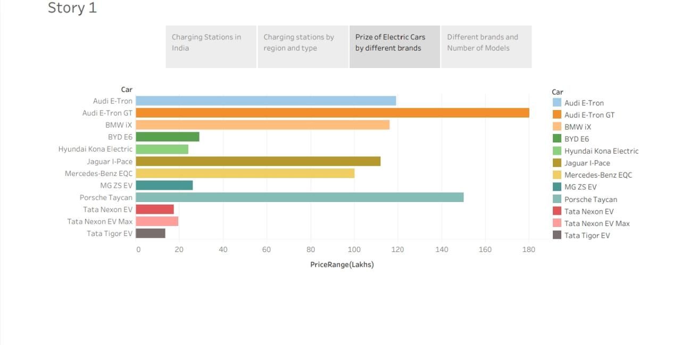

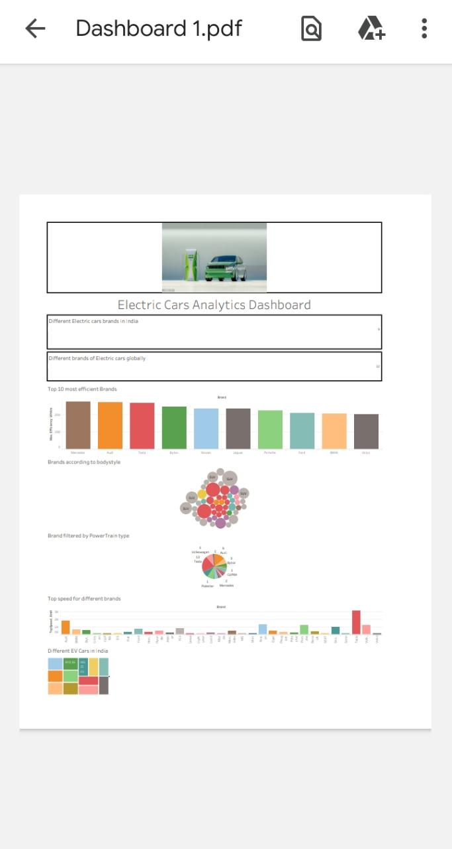

**4. ADVANTAGES AND DISADVANTAGES**

4.1 ADVANTAGES

• Better performance

• Easy to charge at home

• Maintenance cost is low

• Electric vehicle have the silent functioning capability

• No fuel is required

• Air pollution is reduced

• Electric vehicles produce no tailpipe emissions

• Easy to charge at home

4.2 DISADVANTAGES

• Electric vehicles have low resale value

• EVs take more charging time

• Sometimes EVs are expensive

• Electric bills are increased by charging the EVs at home

• EVs have less driving capability and speed

• EVs are not suitable for cities facing shortage of power

• Lack of power stations in all places

**APPLICATIONS**

Electric vehicles are mainly used for road transport. Electric vehicles lack gears. They power an electric motor which rotates the wheels by storing the electricity in a battery. EVs are used in electric motor, batteries, inverters, and in charging stations because of its durability, reliability and superior electrical conductivity. Electric vehicles make the road trip easy and comfortable.

**CONCLUSION**

Nowadays the world became new day by day. There are many companies with new inventions which became the part of our life. Similarly electric vehicles play a major role in our society. We should make use of these vehicles.

**FUTURE SCOPE:**

The global market for electric vehicles is growing continuously. The exponential growth is being driven by various factors, including concerns for pollutions. Consumers in India are looking for low price but high quality. So electric vehicles are increased. I think electric vehicles are very important for the future of transportation.

“IN ORDER TO CLEAN AIR IN CITIES,

YOU HAVE TO GO ELECTRIC”

“THE TIME IS RIGHT FOR ELECTRIC

VEHICLES”